Design Diagram:

[Client] --> [API Gateway] --> [AWS Lambda] --> [DynamoDB] 🡪 [S3 (Optional)]

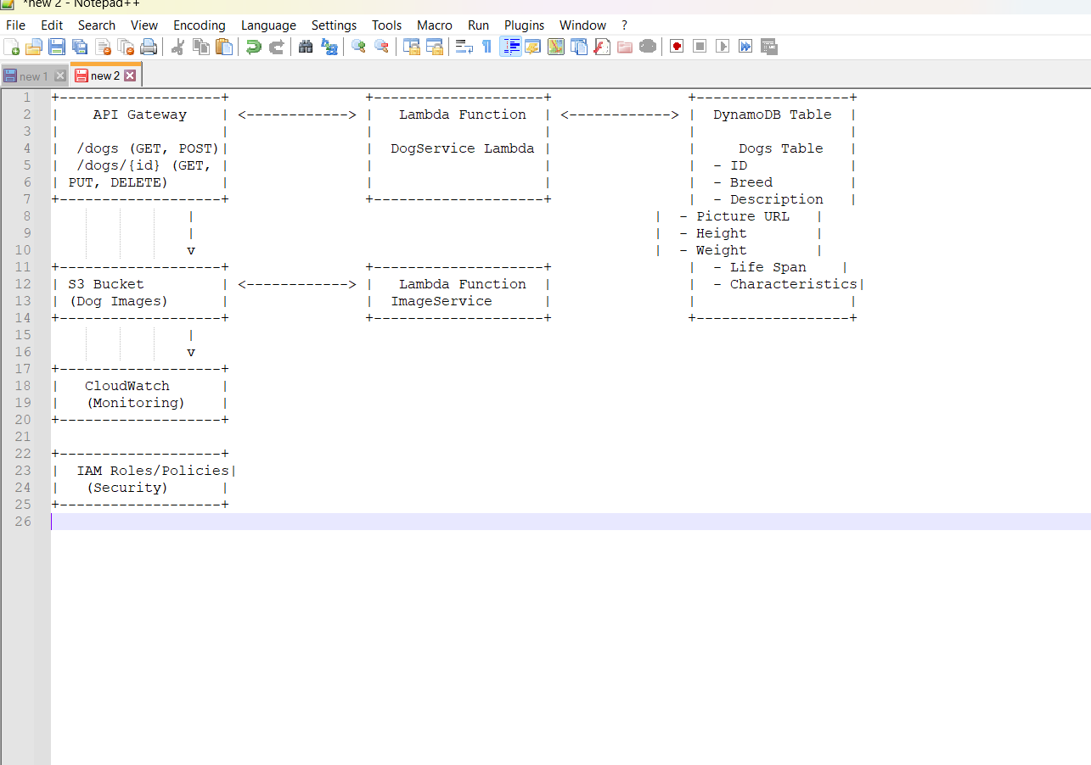

Swagger 2:

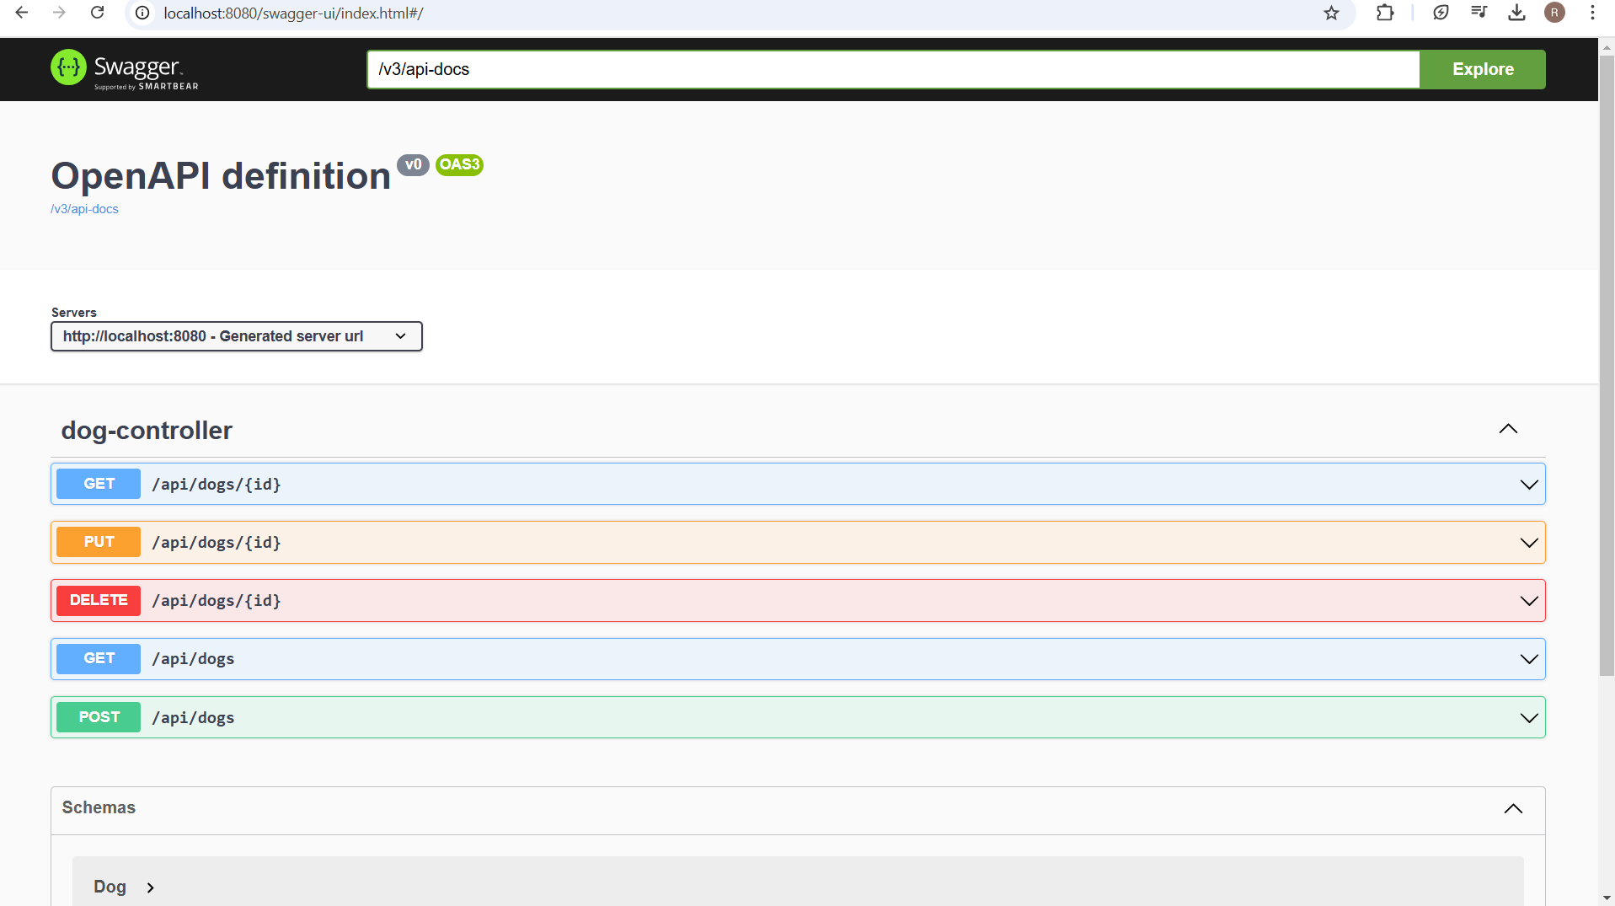

POST:

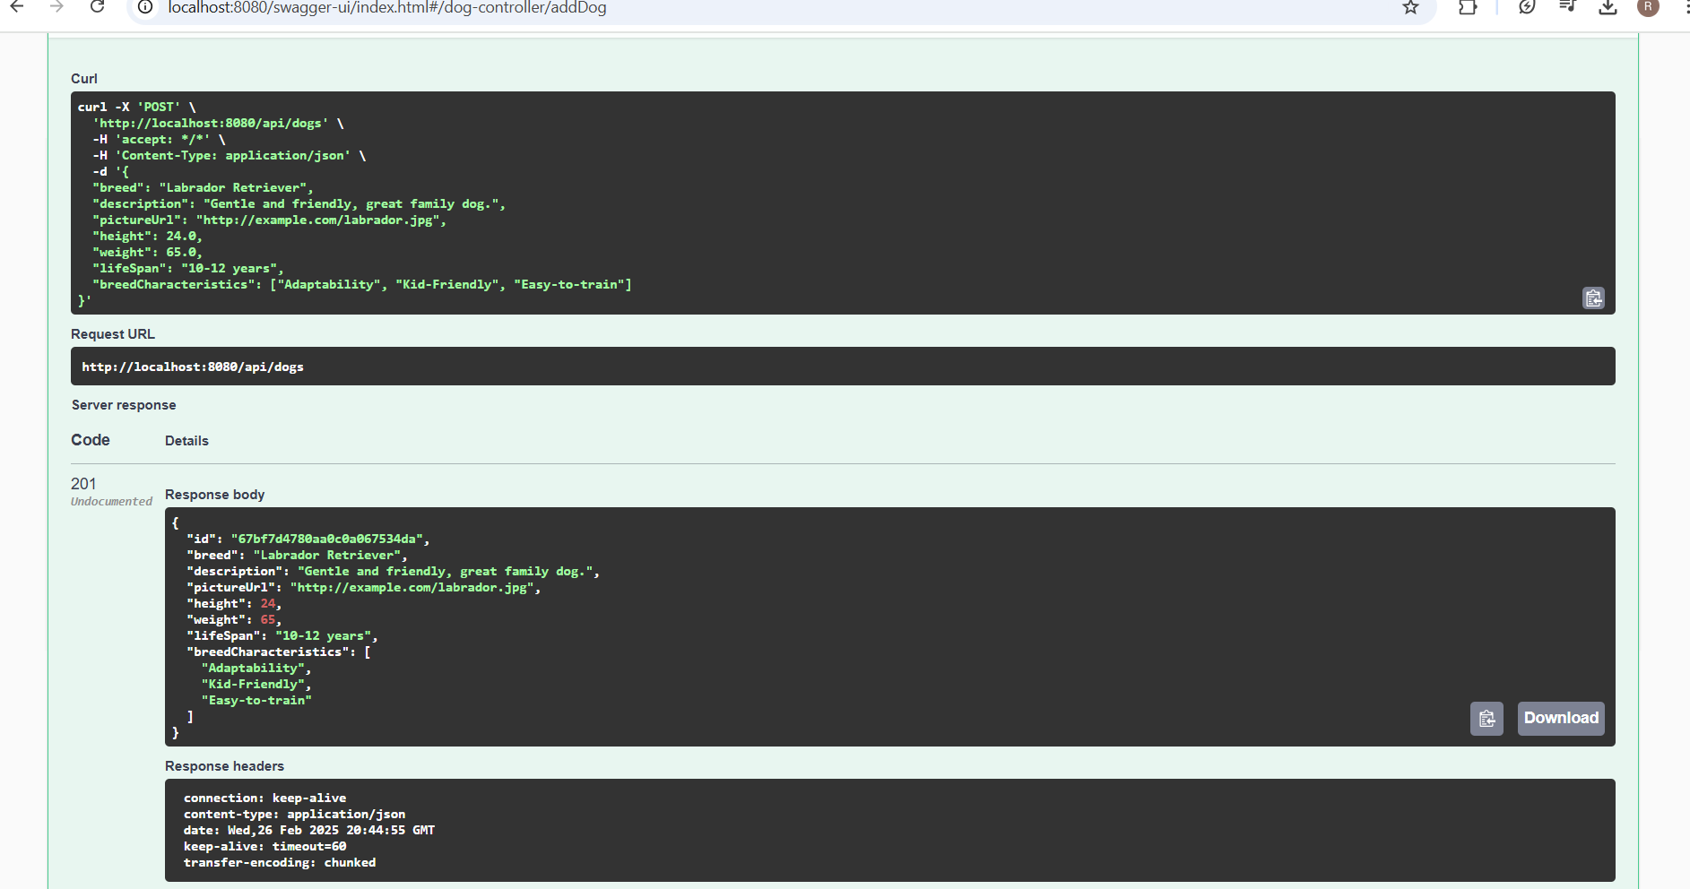

GET:

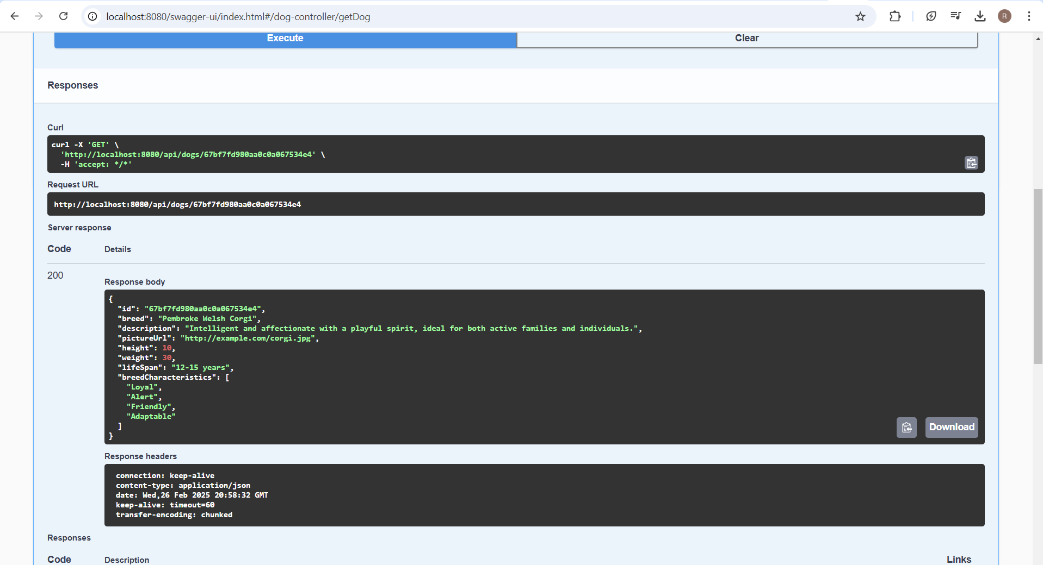

GET: Not Found with ID

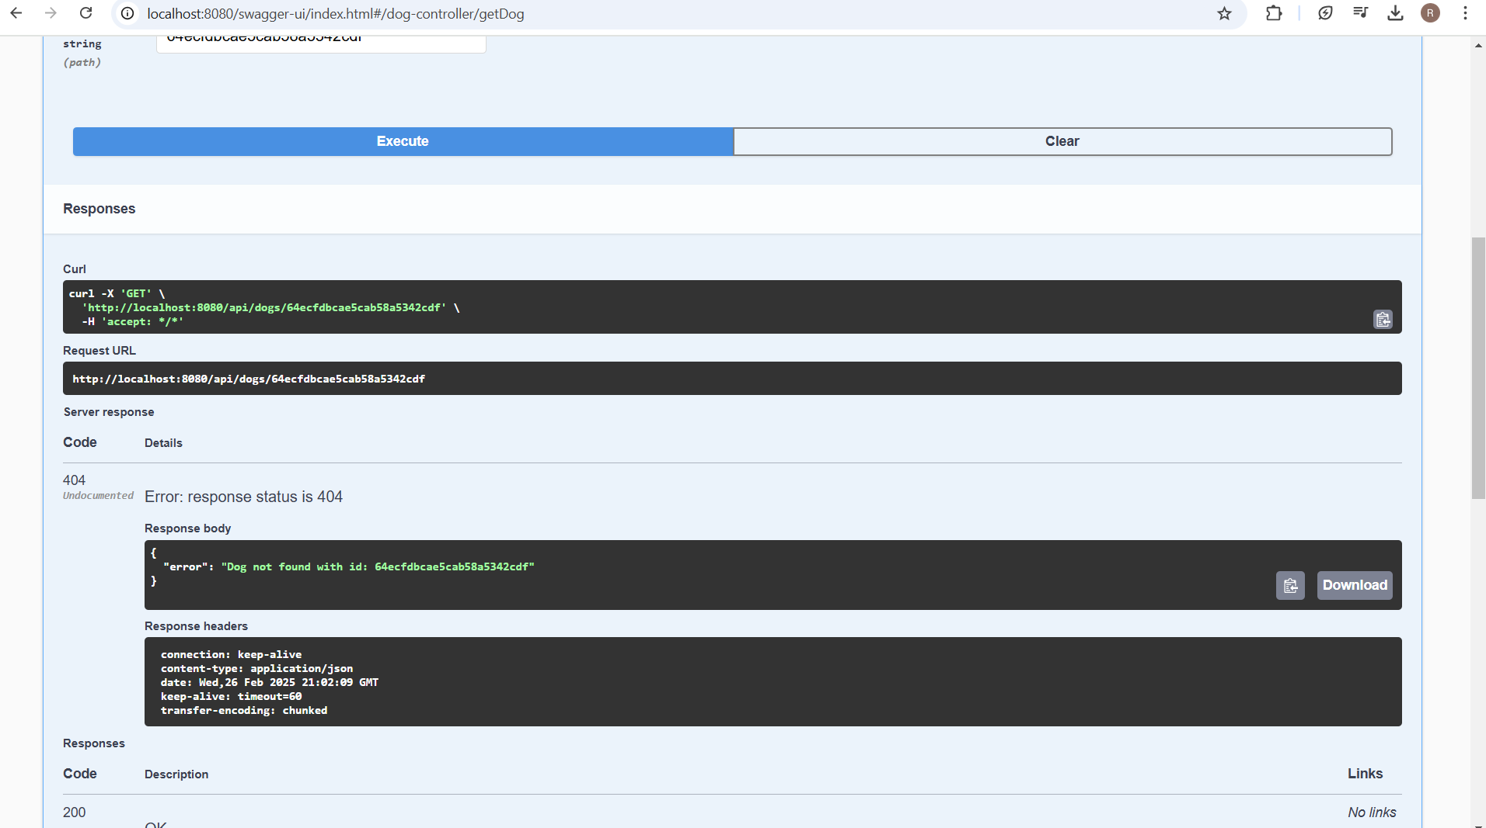

PUT: updated fields

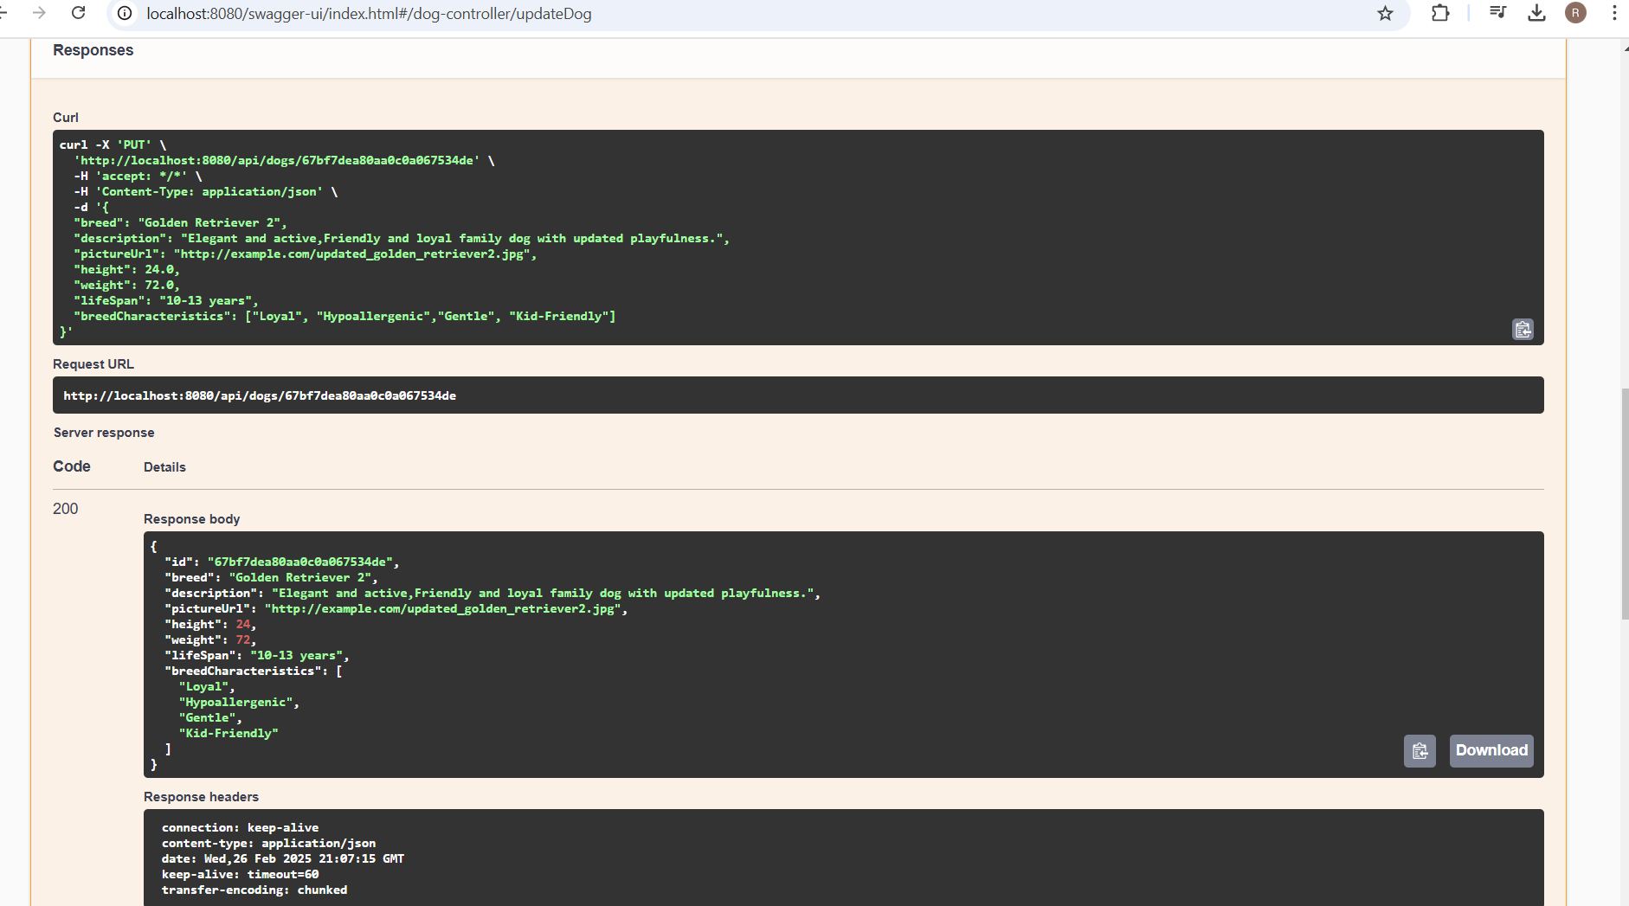

Pagination: GET

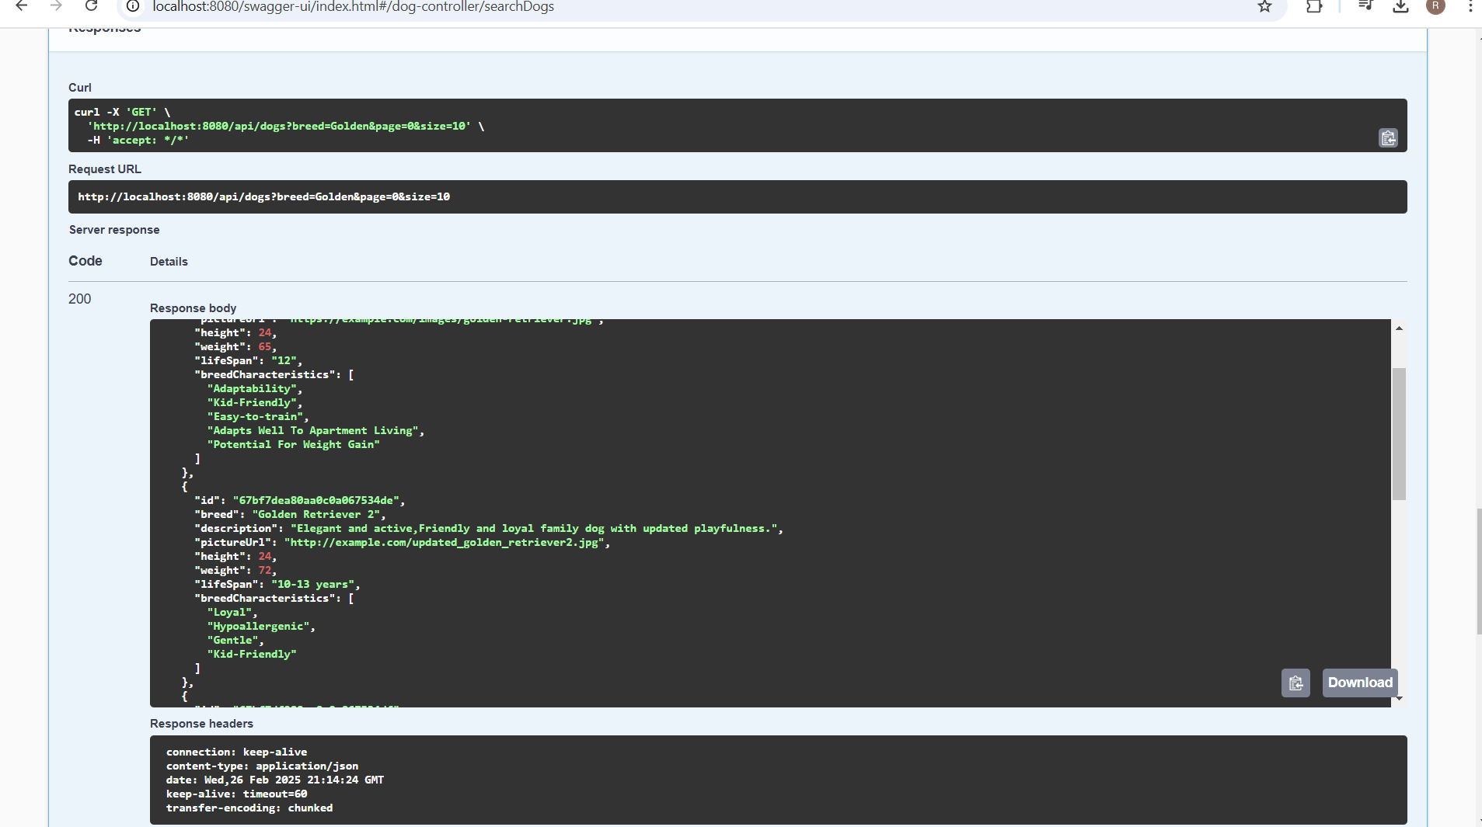

DELETE:

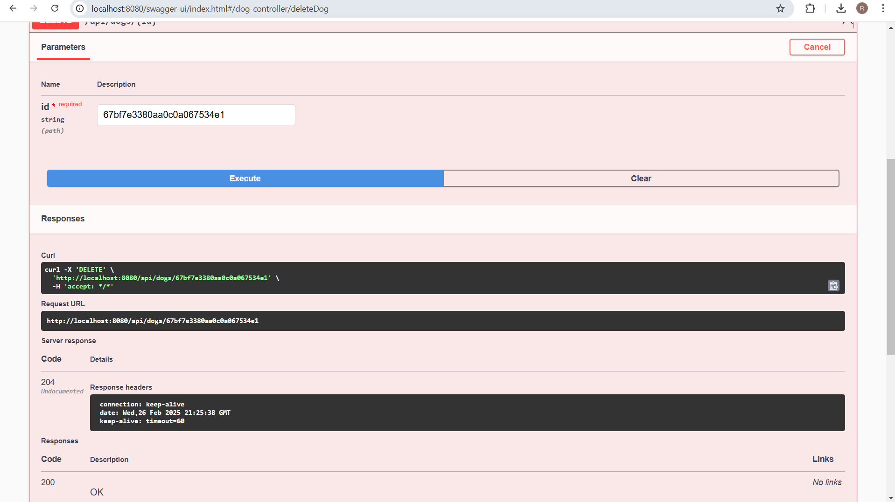

Mongo Express:

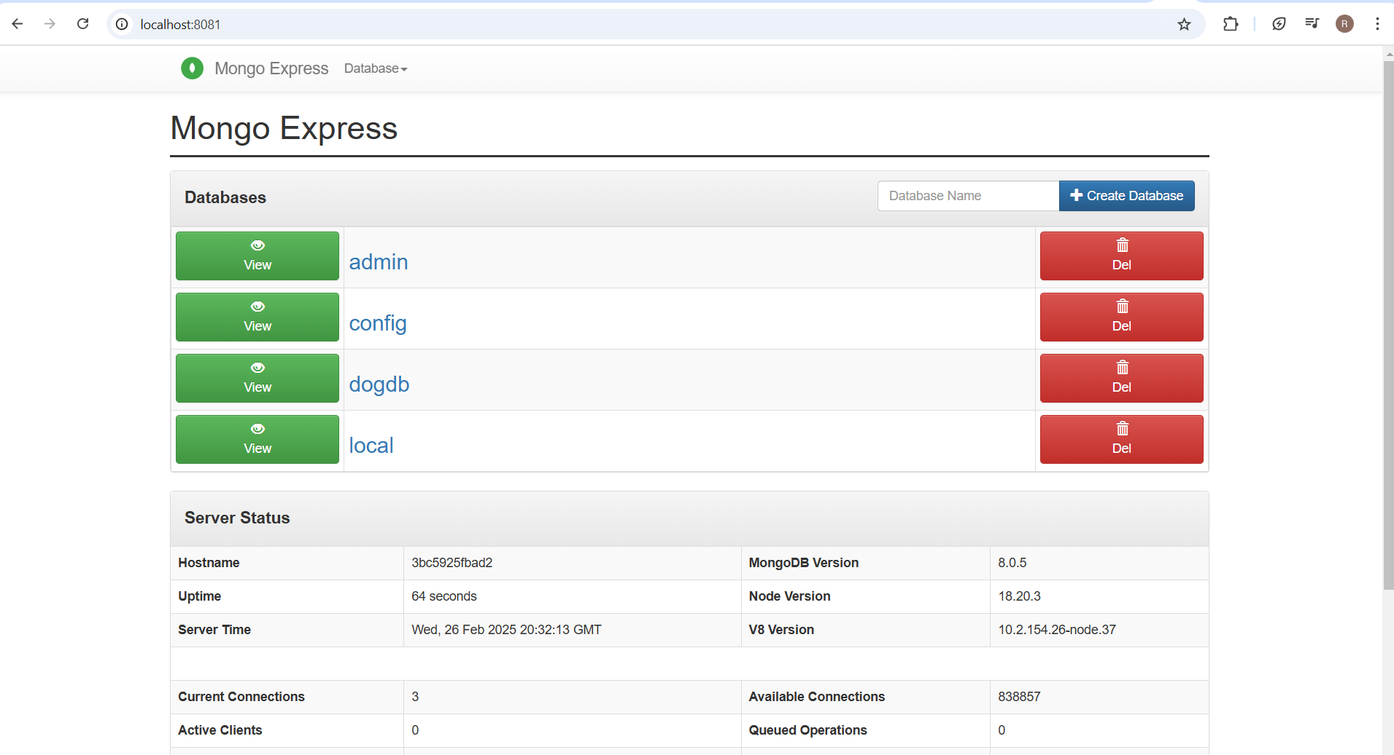

DOCKER FOR MONGO DB and MONGO DB Express

3 containers

1. Dog-crud app
2. Mongo db
3. Mongo express

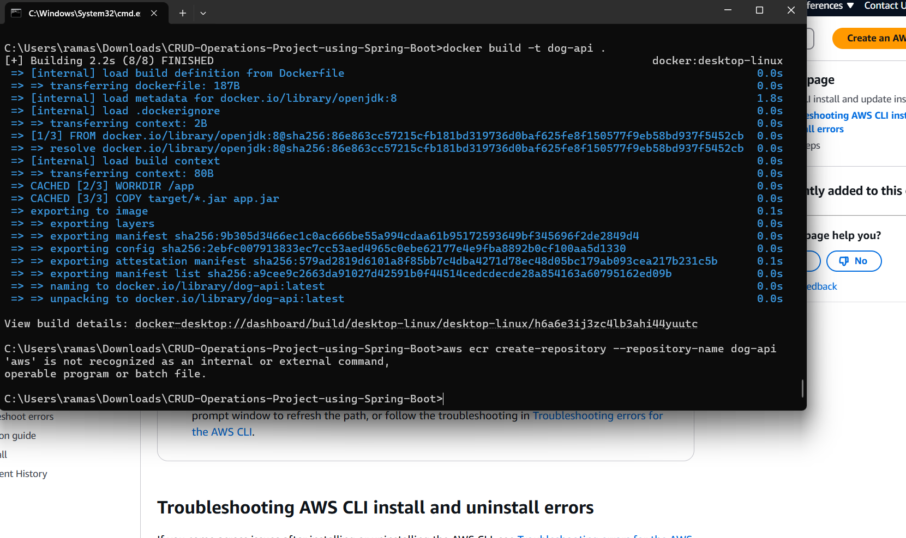

To publish an api requires payment verification.

